Under Armour UA Social Media Marketing Campaign
Name
Institution

Company Background
Under Armour is a company founded by Mr. Kevin Plank in 1996 and headquartered in Baltimore in the United States of America. Mr. Plank also acts as the company's executive chairman and brand chief (James & Whitney, 2018). Together with its subsidiaries, it ventures into the apparel manufacturing industry by developing, marketing, and distributing branded performance apparel, accessories and footwear for women, men and youths in Europe, Africa, Middle East, America and the Asia-Pacific regions. Accessories offered by the company include but are not limited to bags, gloves, sports masks and headgear. Currently, the company is a $15 billion athletic-apparel business empire with over 15 000 employees worldwide (James % Whitney, 2018). The company uses various channels to communicate with its audience. The company uses sports magazines such as Runners World to showcase their products. It also advertises its products via television adverts.
The company understands the power of social media marketing in reaching out to a vast audience. It has its website where it advertises events and new products. For instance, it has several social media platforms, Under Armour Email services, company Facebook account, Instagram, YouTube channel, Twitter, Pinterest, and Wikipedia listing (Appendix 3). The company uses famous people, especially celebrities and renowned athletics, to advertise its products (Armour, 2021). The main objective is to win the followers of such influencers to become part of the company's customers (Appendix 1). The main aim is to continue to escalate consumer engagement and brand awareness by aligning the company's marketing efforts and digital sales. The company also used the #IMPRETTY digital campaign to appreciate women for their career achievements and entice them to buy Under Armour Women Products (Appendix 5).
The company's previous social media campaigns include its recent user-generated content to tell its high-performance story effectively. For instance, the company used shopper reviews, customer ratings, images, and videos, shoppers donning its products, including feedback from its "wear-testers" like Stephen Curry and Dwayne Johnson (Gray, 2019). It also used an emotional mobile video campaign that participants on social media platforms shared. The campaign aimed at creating an emotional bond with customers to forge customer loyalty. It emphasized the need for the participating runners to prove their love for running. Runners posted photos, map tracking and a statement explaining why they were included in the UA Run Camp (Appendix 2). Each post had to include the hashtag #earnyourspot for a chance to be chosen.
Situation Analysis
Internal factors— The corporate culture of Under Armour company emphasizes an environment that enables employees to do their best, be their best and get better every day. The company believes it is more robust when individuals from different backgrounds, perspectives and experiences come together to support athletes across the globe (Appendix 8). The company embraces diversity to enable it to deliver the most innovative products that improve athletes and drive the business's success. The company's mission is to advocate for teammates with varied abilities through inclusion and awareness (James & Whitney, 2018). The company celebrates all capabilities, including service animals, support for parents and children, injuries and mental health. The company has a unique program to empower Blacks to grow professionally via community, career and consumer-based initiatives. It also has women and military veteran mentorship programs. Despite its colourful mission, the company has been accused of promoting a troubling workplace culture where some executives and employees expense visits to strip clubs.
The company that started small in Plank's grandmother's basement has grown into a giant empire with over 15,000 employees worldwide and 310 stores around the globe. The company registers an average of $4.9 billion in earnings annually (Mohamad, 2019). Also, it has an impressive list of renowned athletes, for instance, Tom Brady, Michael Phelps and Lindsey Vonn, who have brand endorsement deals. Reports indicate that the company still struggles to learn the spelling of inclusiveness and diversity, as characterized by the dominance of males in the positions.
External factors— The apparel industry is growing at a promising rate of 4.8%, and it is anticipated to become worth $ 900 billion in market value by 2021. This gives the company a plethora of opportunities to expand its empire to other parts of the world, such as in the Middle East and Asian countries. The trade war between the US and China has suffocated its goods consumption in China, increasing the price of its products. The company utilizes technology to reach its customers by selling its products online. Most UA customers are sports enthusiasts and those with the zeal to lead a healthy life. 69% of its customers are males, while most of its customers are aged between 18 and 30 years (Mohamad, 2019). The company's close competitors include Adidas, Nike, New Balance and Puma.
SWOT analysis— the significant strength of Under Armour is that it is expanding to other sports and has a vast potential for expansion, considering that it is a new company. Also, its products differentiate it from its competitors because of its highly engineered products that guarantee comfort in weather extremes. UA has a substantial community involvement via its programs, for instance, UA Win Global and UA freedom. To add, its constant revenue growth is a significant economic cushion for the company, while its increase in share price boosts investors' confidence.
The major weaknesses of UA are that it is a new company with a limited presence and stores in few markets. The company's brand athletic cups were recalled for the possibility of causing injury to users. The company's significant opportunities include tapping online shopping to increase sales. Its partnership with the NBA league will lead to high brand visibility, primarily to kids. It has the chance of expanding to unexploited markets in Europe, Asia and Australia with its constant innovation as the leading force in attracting consumers (Armour, 2021). Some of its significant threats include stiff competition from Nike and Adidas that have a high customer base (Appendix 4). Its brand awareness is still low compared to other brands, while some of its products like athletic and chin straps may lead to injury hence harming the brand name.
Campaign Objective
The company needs to target kids in the promotion of its brand. Kids comprise the largest consumer market in team gear, sports apparel and equipment. UA should win at least 10 million children in the coming five years.
Target Audience Profile
Children form a significant customer segment that companies ignore. They lead in the buying of sports gear and equipment. Surprisingly, children also influence household spending and decision-making when it comes to buying sports apparel. Also, parents are increasingly investing in the child in the name of love; hence, the child's choice matters a lot. A higher affinity for a specific brand benefits the chosen brand in terms of sales and brand loyalty (Armour, 2021). Currently, at least 40% of kids aged between 5 and 18 play an organized sport every year in the United States of America (Appendix 7).
The number includes 21 million children involved in non-school child-related sports, for instance, soccer, volleyball, lacrosse, baseball and gymnastics. More families can afford to spend over $ 100 000 on sports (See appendix 6). Traditionally, sports are organized via community programs, for instance, soccer clubs. The youth sports of the US is a $15 billion business with an impressive growth of 5% annually (Armour, 2021). Under Armour needs to seize the emerging power of children in the apparel sector to harvest the segment's lucrative returns. Also, the move will enable the company to have a brighter future of growing with the children into the future markets.

References
Armour, C. (2021). The regulator: Change in the weather. Company Director, 37(1), 34-35.
Gray, A. A. (2019). Brands Take a Stand for Good: The Effect of Brand Activism on Social Media Engagement.
James, C. R., & Whitney, K. (2018). Under Armour: repositioning for the global stage. The CASE Journal.
Mohamad, N. (2019). Determinant Factors of Company Performance in Under Armour Inc. Available at SSRN 3498357.

Appendix

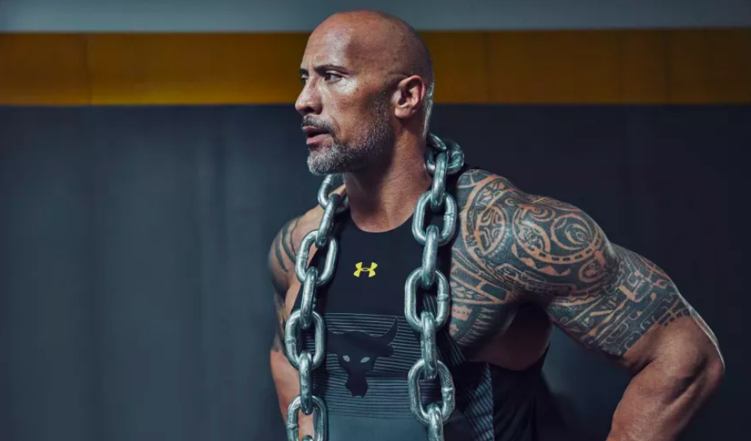
Figure 1. The use of influencers by UA in marketing and endorsement deals

Figure 2. UA RUN on Twitter

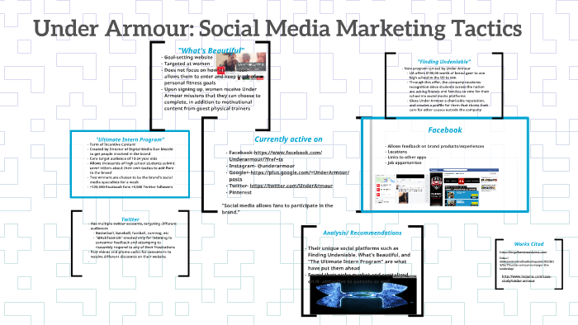
Figure 3. Under Armour Social media presence

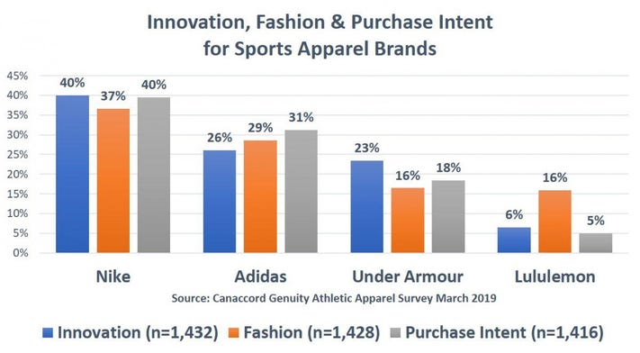
Figure 4. UA competitors
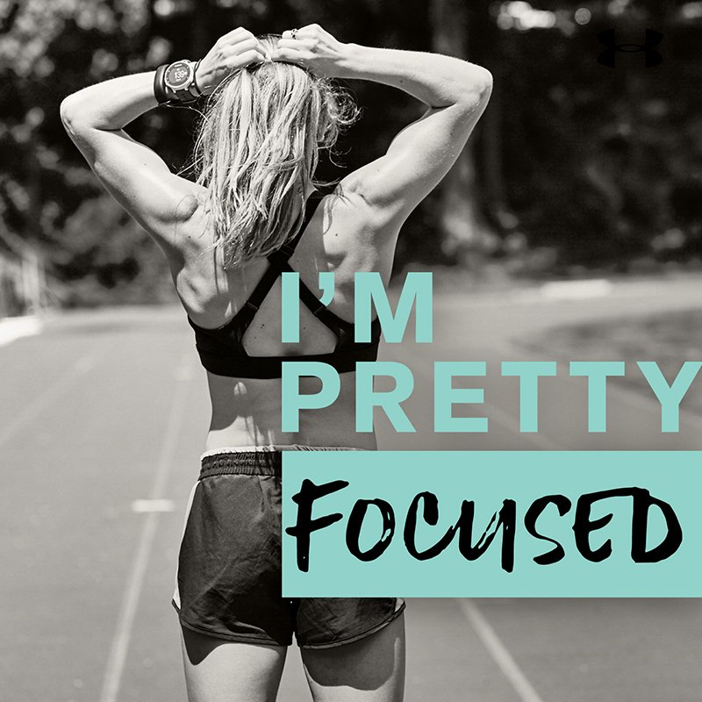
Figure 5. UA IMPEETTY campaign
.

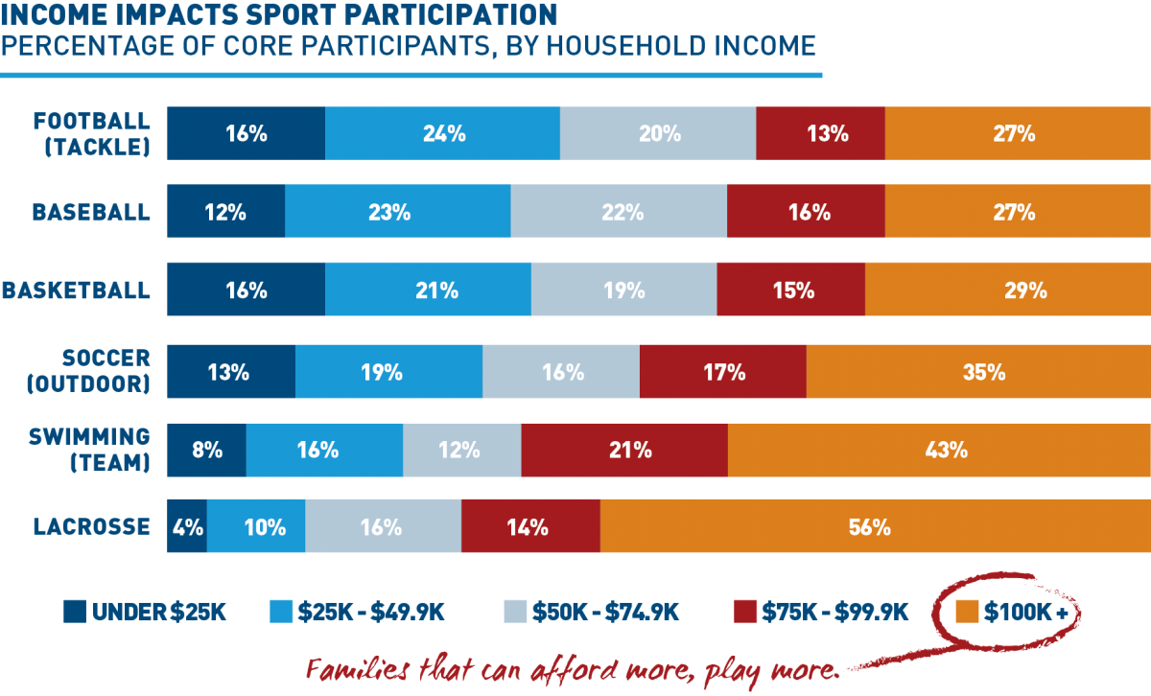
Figure 6. The apparel buying power of parents in the USA

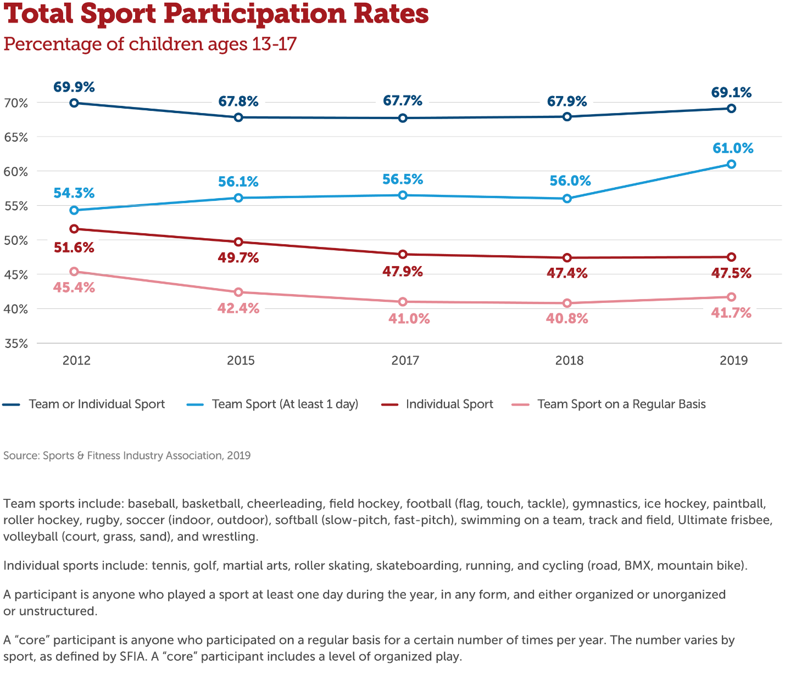
Figure 7. Sports participation by youths

Situation Analysis
Internal factors | - Excellent corporate culture that encourages employees to do their best  - Practices workplace diversity  - The company's mission is to advocate for teammates with varied abilities through inclusion and awareness  - The company celebrates all capabilities for instance mental health  - has a unique program to empower Blacks to grow professionally via community, career and consumer-based initiatives  - has women and military veteran mentorship programs  - has over 15,000 employees worldwide and 310 stores around the globe  - The company registers an average of $4.9 billion in earnings annually  - Has an impressive list of renowned athletes who have brand endorsement deals
External factors | - The apparel industry is growing at a promising rate of 4.8%  - The company can expand to other markets  - The US-China trade war that has led to price increase  - Online selling of its products  - Competition from established companies like Adidas and Puma  - Most UA customers are sports enthusiasts and those with the zeal to lead a healthy life.
SWOT analysis | Strengths  - the potential of expanding to other sports for it is a new company  - product differentiation due to its highly engineered products that guarantee comfort in weather extremes.  - Excellent relations with the community  - constant revenue growth and increase in share price boosts investors' confidence.  Weaknesses  - It is a new company with a limited presence and stores in few markets.  - a recall of athletic cups for the possibility of causing injury to users.  Opportunities  - tapping online shopping to increase sales.  - Its partnership with the NBA league will lead to high brand visibility  - It has the chance of expanding to unexploited markets in Europe, Asia and Australia with its constant innovation  Threats  - stiff competition from Nike and Adidas that have a high customer base  - low brand awareness compared to other brands  - some of its products like athletic and chin straps may lead to injury hence harming the brand name

Figure 8: Situation analysis

